Decimal and Binary System

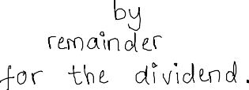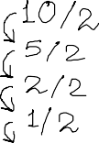

12 January 2022 18:26

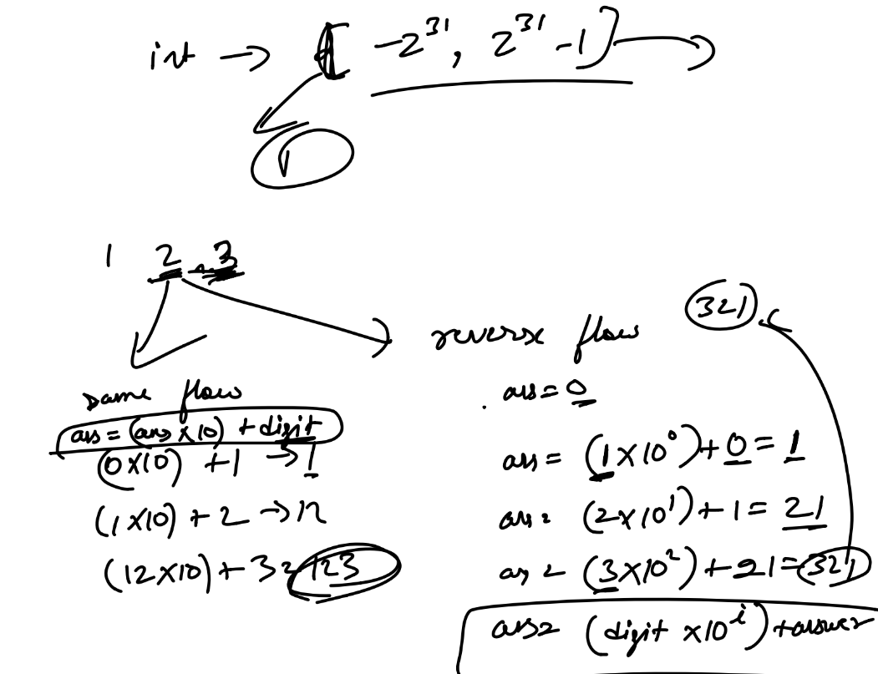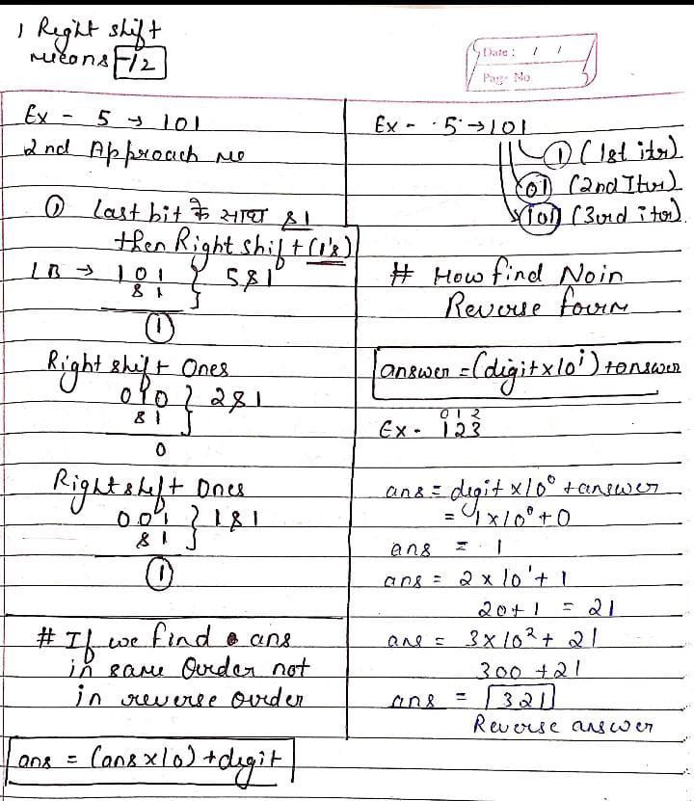

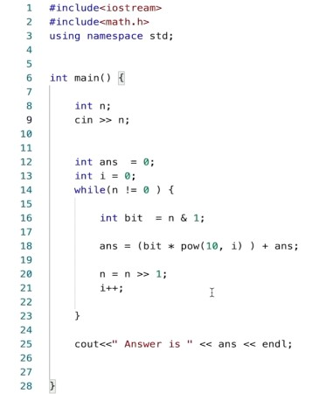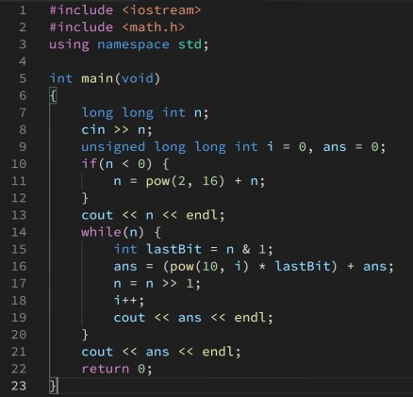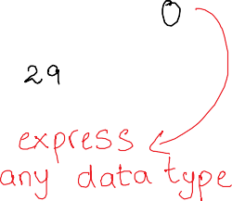

*****

Input To hum bit me denge

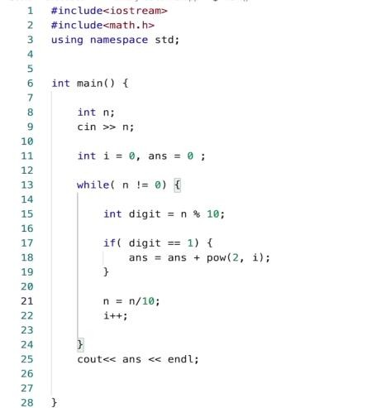

so hume us input ka bit nhi

nikalna Hume us bit ko

1 by 1 element lena hai

Using Modulo and then jo

le lia usko remove from

given input bit

**As we know input me hume bit de rha hai**

**Agr hum us bit ko ek no ki tarah treak**

**Krke uska bit nikalenge to wo bahut bda**

**Hojaega**

**That’s why hume us bits input ko as a integer**

**treat krna pdega But Agr Suppose hum bit nikalte hai to**

**Hume multiply 2 wala game khelne me**

**problem hoga**

